Digital Image Processing
Final Report
Varsha Sayyaparaju 201030097
Prateek Goel 201001067
Aditya Singh 201002055

- Problem Statement:
Goal: To identify the various hand gestures involved in Indian classical dances in a given image.
Purpose: Indian classical dance is a cultural art form which conveys meaning in every step. It is, however, not palatable to the untrained eye. To appreciate the art form, one needs to know the story behind every single movement. This project is an endeavor that will hopefully transcend into a tool that sends across the intended message clearly to anyone interested. We envision a tool that enables real time tagging of images and videos with the mudras. This project is merely a stepping stone, an initiation towards this goal.

Nature of Work: Own idea implemented with prior knowledge and references from a couple of research papers.
Block Diagram:
Hand Segmentation
Skin detection
K-means clustering
Boundary Extraction
Neighbourhood processing
Morphological opocessing
Fingertip Detection
K-Curvature
Preprocessing
Postprocessing

Deliverables:
  - Minimum: Recognition of single hand gestures with and without accessories.
  - Maximum: Recognition of single and two hand gestures with accessories, i.e. mehendi, bangles, rings etc.

Workload Distribution:
- Interim 1:
- Varsha:
  - Dataset collection
  - Skin color detection
- Aditya:
  - Basic Thresholding
  - Boundary Extraction
- Prateek:
  - Finger-tip Detection
- Interim 2:
  - Varsha:
    - Dataset collection
    - Improvements:
- Skin-detection
- Boundary Extraction
- Finger-tip Detection
- Aditya:
- Segmentation of hand
- Skin detection
- Color based k-means clustering
- Edge detection
  - Sobel
  - Prewitt
  - Gradient
- Prateek:
- Distinguishing between hands
- Boundary Extraction
- Watershed Transform
- Final Presentation:
- Varsha:
- Segmentation of Hand
- Mehendi Removal
- Aditya:
      - Boundary Extraction
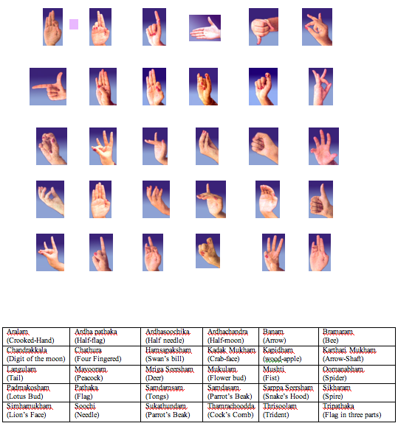
- Prateek:
      - Finger-tip detection

- Obstacles Faced:
- Interim 1: Single Hand Mudras without accessories in plain and complex background
      - Dataset:

      - Methods used:
- Thresholding
- Skin-color detection
- Boundary extraction
- Finger-tip detection
- Knowledge Required:
- Basic thresholding
- Color-space models:
- HSV
- YCbCr
- Morphological Operations:
  - Binarization
  - Erosion
  - Dilation
  - Region Filling
- Distance metrics: Euclidean distance
- Process Overview:
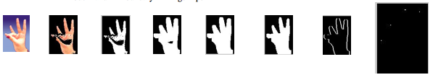
Original -> Hand Extracted -> Binarized -> Dilated Hand -> Region Filled -> Eroded Hand -> Boundary -> Finger-tips

Achievements:
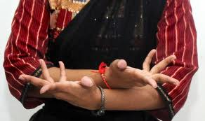
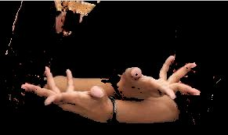

Image 1 Image 2
Hands in complex background are segmented using skin-detection
- Challenges:
  - Improper hand extraction because of skin-detection
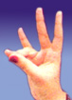
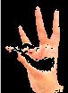



Image 3 Image 4 Image 5 Image 6
Observations:
    - It can be noticed that when the amount of light on the hand is a lot, skin-detection fails as in images 3 and 4
    - When light is less in a region, then also the detection process fails, as can be seen in image 5 and 6
  - Distortion of hand due to morphological operations
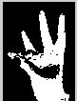
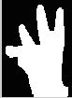
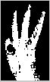

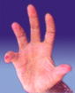
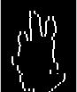

Image 7 Image 8 Image 9 Image 10 Image 11 Image 12
Observations:
- The fingers of have increased in width
- In Image 12, the hand shape is completely lost
- Improper boundary extraction, i.e. not fully connected contour
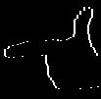

Image 13 Image 14
Observations:
- It can be seen that the index finger boundary is not completely connected
- The bottom of the hand is also not fully connected
- Improper finger-tip detection
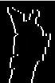

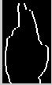


Image 15 Image 16 Image 17 Image 18
Observations:
    - In image 18, a false finger-tip detected at the left bottom,
    - The algorithm detected all fingers correctly.
Is finger-tip detection enough for classification?

- Interim 2: Improvements and Double Hand Mudras without accessories in complex background
  - Improvements:
    - Skin-detection
    - Boundary Extraction
    - Finger-tip detection
  - Knowledge Required
    - Color Models: RGB, HSV and YCbCr
    - Neighborhood processing
    - K-curvature
  - Changes implemented:
    - Skin-detection: Previously, we threshold only in the H and Cb, Cr planes. Then we changed to thresholding in the Cr, Cb, H, S,V, R,G, and B planes. Which gave better results:


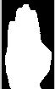

Image 21 Image 22 Image 23

Observations:
- The whole in the middle of the hand is filled
- Boundary Extraction: Morphological operations were causing distortion in the hand and causing breaks in the boundary. Therefore, neighborhood processing was used to give better results:

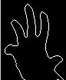

Image 24 Image 25 Image 26
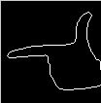

Image 27 Image 28 Image 29
Observations:
- The hand is in the exact shape as in original image
- There are no breaks in the boundary
- Finger-tip detection: Instead of using Euclidean distance and looking for points above a threshold, using the k-curvature method gave better results. The process involves looking for concaves and convexes in the image:
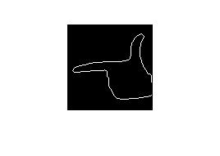
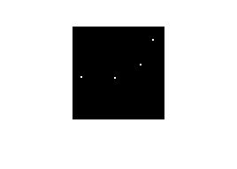

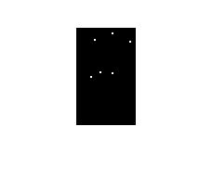
Image 30 Image 31
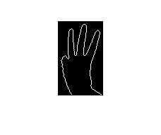

Observations:
    - Finger is not detected, but boundaries of fingers are detected which would be useful in the case mentioned in challenges in Interim 1. As can be seen below:


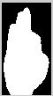


Image 34 Image 35 Image 36 Image 37
Double Hand Mudras:
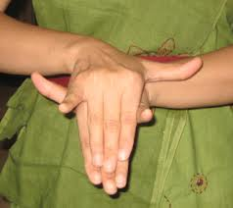
Dataset:
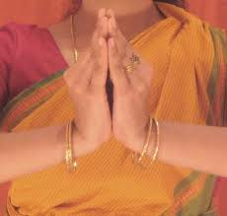
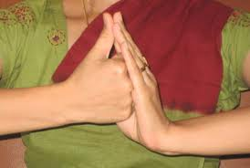
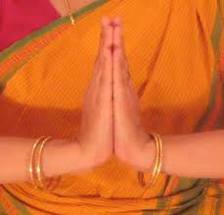
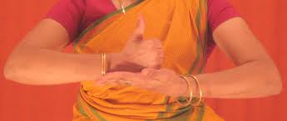
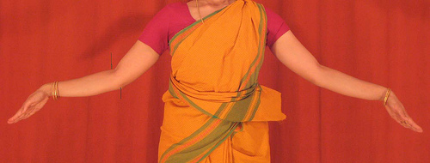
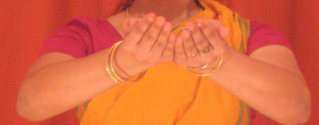
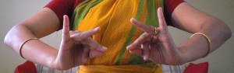
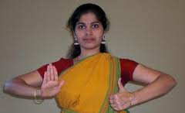
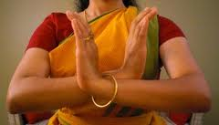
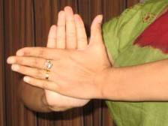
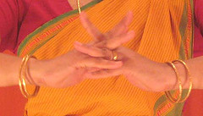
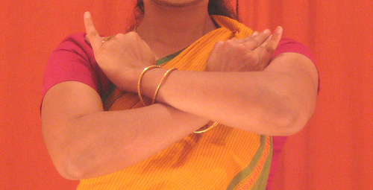
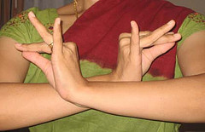
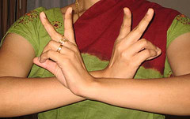
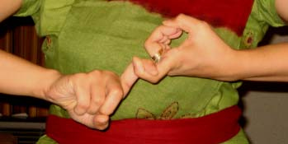
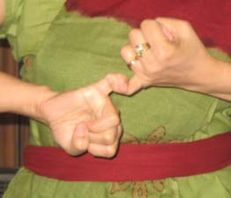
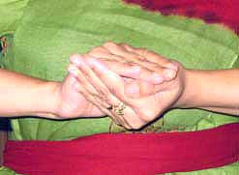
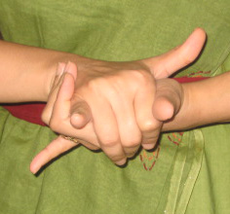
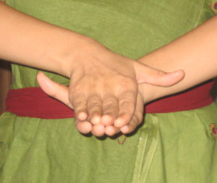
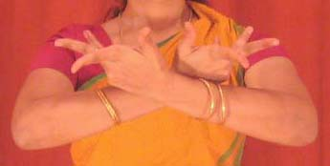
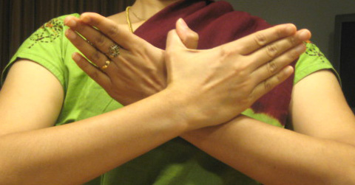
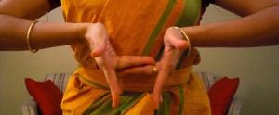

- Methods used:
  - Segmentation of hands:
    - Skin-detection
    - Color based k-means clustering
    - Edge-detection:
      - Sobel
      - Prewitt
      - Gradient
  - Distinguishing between hands
    - Boundary Extraction
    - Watershed Transform
- Knowledge Required:
  - Color Space Models: HSV, RGB, YCbCr, LAB
  - Sobel, Prewitt, and Gradient edge detection methods
  - k-means clustering algorithm
  - Neighborhood processing
  - Watershed Transform
- Process overview:
Get Hand from Complex background -> Distinguish between hands -> classify
- Challenges:
  - For cases, in which the background had a color close to skin color, segmentation was hard using skin-detection because the background was detected too:
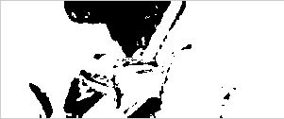

  - Since we couldn't get only the hands for such cases, we thought we would try edge segmentation, and try getting only the hands out. We thought since hands are center of attraction, maybe lighting conditions are in such a way that the hands would stand out more. Therefore, we figured the edges of the hand would be brightest compared to that of background edges. Not much success achieved in this process either, because as we predicted hands edges were the brightest in the image, but the threshold changed for each image:
Threshold: 0.09
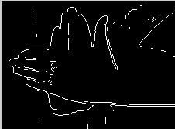
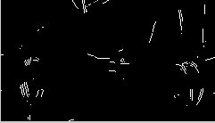

Observations:
    - For the same threshold, the hand can not be segmented in different images.
  - Boundary Extraction was a problem, because since the hands are overlapping in some cases, it caused problem in feature extraction:

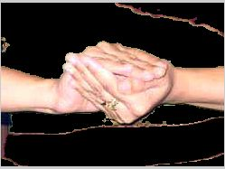
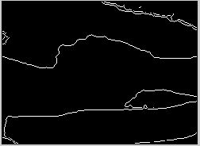
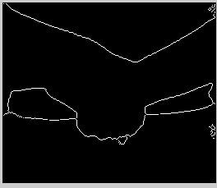
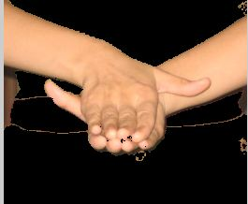

  - Watershed Transform: This is used to differentiate between hands. But it did not give the results we wished:

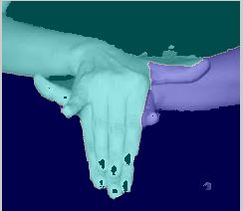
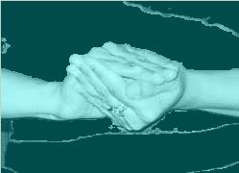

Observations:
    - In image 47 it can be seen that the finger on the left is part of the right hand, but is still detected as a finger of the left hand which is not the required results
    - The overlapping hands are not recognized. The fingers in the bottom are still considered as part of the hand above.
    - In Image 49, both the hands are considered as being in one cluster, which is also not the results we want.

- Final Presentation: Single hands with accessories in addition to previous work
- In plain background
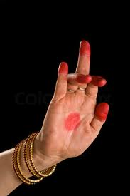
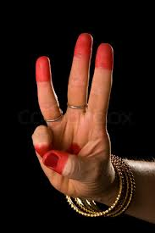
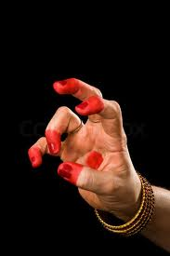
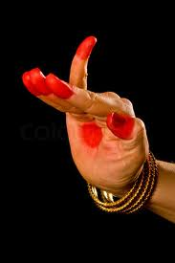
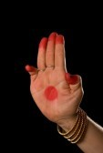
- Dataset:
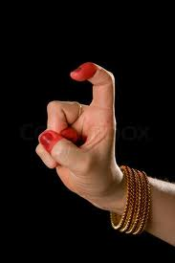
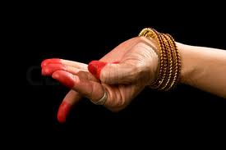

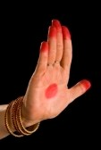
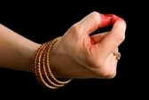

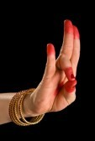
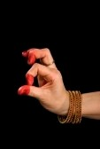

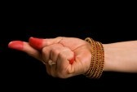

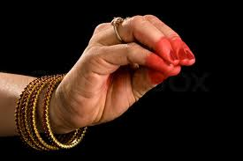
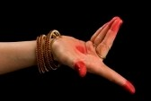




- Overall Process:
  - Mehendi Removal
  - Binarization of hand
  - Boundary Extraction
  - Fingertip detection
- Knowledge Required:
  - Understanding the RGB color model
  - Thresholding
  - Neighborhood processing
  - k-curvature

- Subprocess I: Mehendi Removal
  - Method:
    - Take an RGB image
    - Consider only the red plane
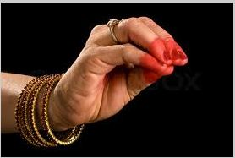
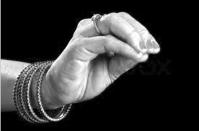
  - Results and Observations:
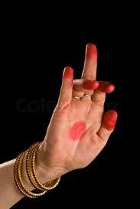
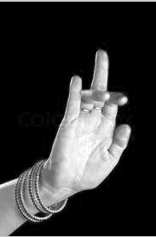

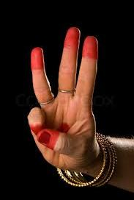
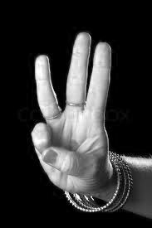

Observations:
- Since the mehendi is red, in the Red plane, the pixel values will be near 255. And we realized that the hand pixels are approximately close to 255 too. The mehendi seems to be removed because in the red plane, the pixel values are all around 255.
- In comparison to the method of detecting the red areas in the image, this is better, because we don't have to worry about segmenting out other parts of the image that contain red in them, such as red bangles:
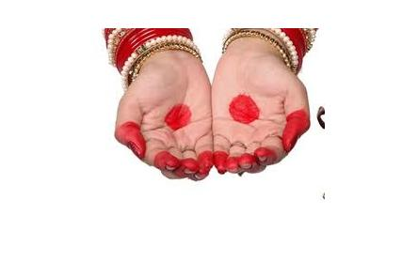
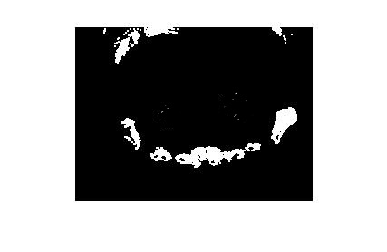

- Conclusion:
- The red parts of an image will blend into background of near 255 pixels if considered only in the R plane.
- This method simplifies the rest of the process, because special methods are not needed to do finger-tip detection.
- Subprocess II: Boundary Extraction:
- Method:
- Simple Boundary Extraction as used before
- Find out if the hand is vertical or horizontal using distance metrics
- Segment out the upper part of the hand, i.e. only palm and fingers excluding the wrist
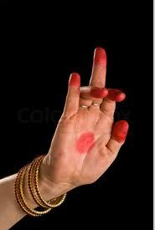
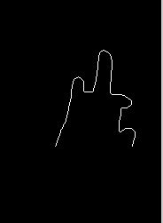
- Results and Observations:
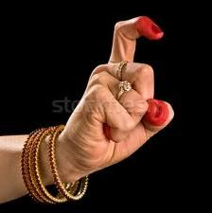
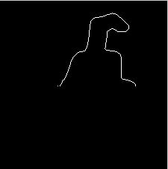
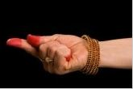
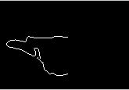
Observations:
    - The bangles are removed from the image if only the upper part of the hand are considered
    - Because of mehendi removal, the boundary extraction has become simple
    - If skin-detection methods were used, then the mehendi region would not be segmented out, and would cause a problem in boundary extraction.
- Conclusion:
    - Skin detection would not have given such a proper boundary
    - Removal of bangles, i.e. the wrist in the image was important so as not to interfere with the finger-tip detection process
- Subprocess III: Finger - tip detection:
  - Method:
    - Same as done for previous Interims
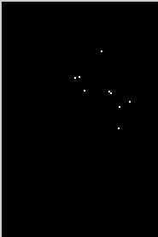
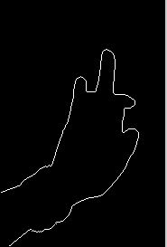
  - Results and Observations:

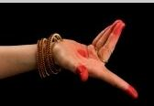
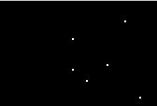
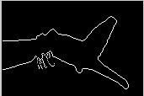
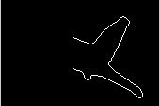

Observations:
- The bangles have caused error in finger detection, because the bumps on the hand caused by the bangles are detected as curvatures
- The effect of the bangles is very prominent in Image 71 and 69.
- Conclusions:
- Finger detection is better when the bangles are removed from the picture
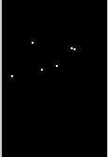
- Overall Process:
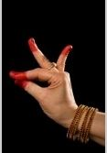
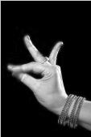
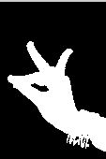
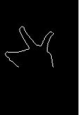
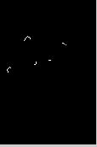

- In complex background:
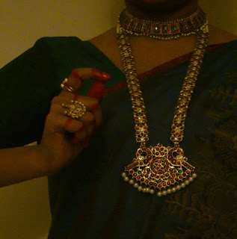
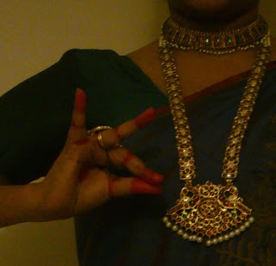
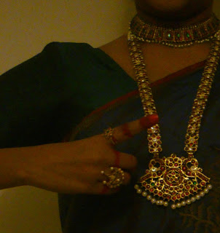
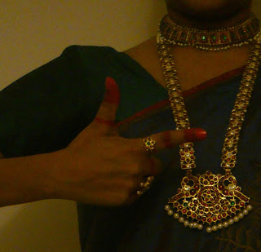
- Dataset:
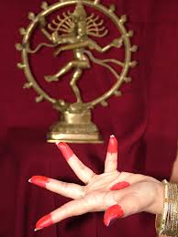

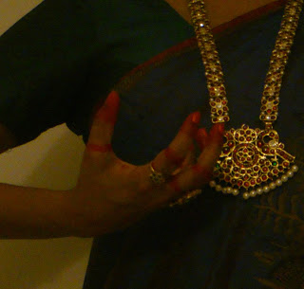
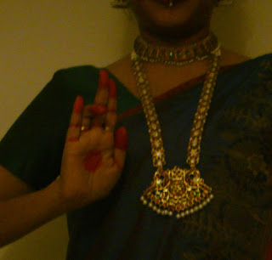
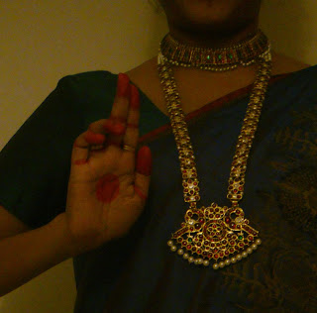
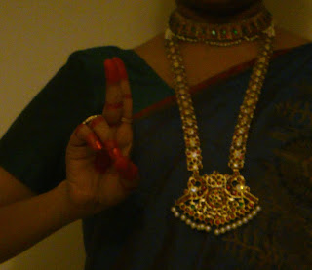

- Method:
      - Segmentation of hand from background
      - Mehendi removal
      - Binarization of hand
      - Removal of unwanted objects
      - Boundary Extraction and Finger-tip detection
Subprocess I: Segmentation of hand from background
Method:
Use color based k-means clustering to segment out areas
Use skin detection to find out which cluster contains the hand
Label that cluster as important and discard other clusters
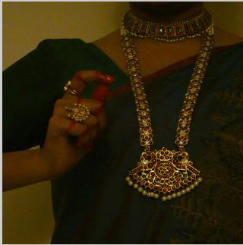
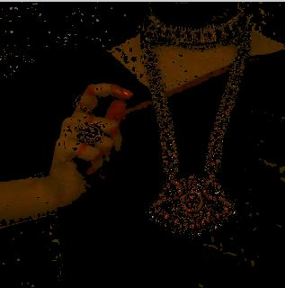
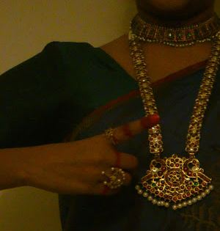
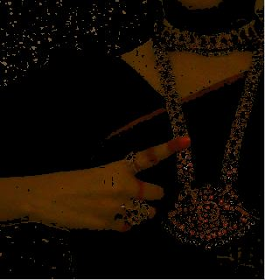
Results and Observations

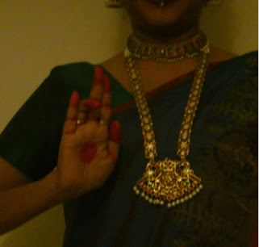
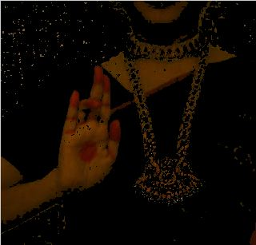
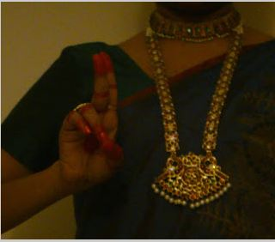
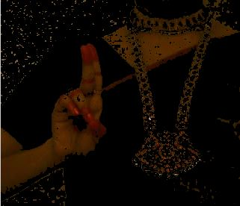

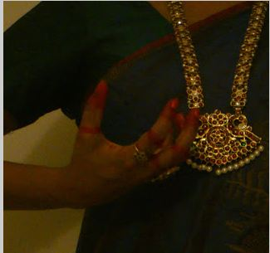
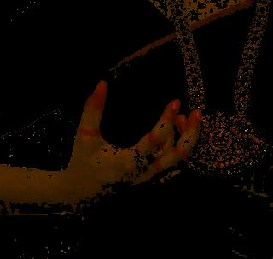

Observations:
          - K-means clustering is clubbing skin color and red together in one cluster, while the golden color and background are clubbed in one, and the green sari is clubbed in another cluster
          - In image 73 and 75, it can be seen that the ring is fully gone or only partially visible, which means that k-means clustering can be treated as a method to remove ornaments of different color as well.
          - The red jewels on the necklace are also clustered in, but the gold part of the necklace is gone. This is prominently visible in image 77
    - Conclusions:
      - K-means clustering works well for segmentation of hands in complex background
      - Subprocess II: Mehendi Removal
        - Method:
          - Make image grayscale by considering only the Red plane
        - Results and Observations:
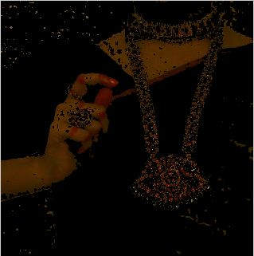
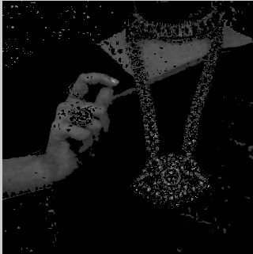

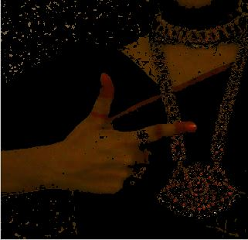
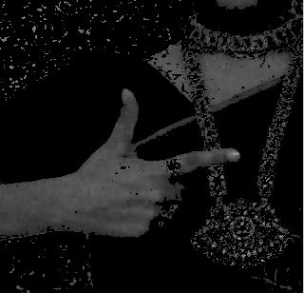
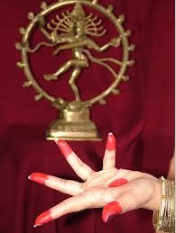
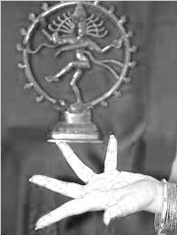

Observations:
- The red jewels are also removed along with the mehendi
- The color of the background of image 94 is same as that of the mehendi
- The image 95 shows that the hand is the brightest compared to the background after mehendi removal, so it can be segmented using basic thresholding.
- Conclusions:
- Since considering only the red plane, leaves only the intensity values of the red colored segments. We can conclude that by considering only the red plane, we are taking only the intensity values which will be same in a given region. Therefore, the mehendi region blends into the skin region.
- Subprocess III & IV: Binarization and Removal of unwanted components:
- Methods:
          - Binarize the image
          - Erode image to break small bonds
          - Keep the largest connected component and remove the rest.
          - Region filling
        - Results and Observations:
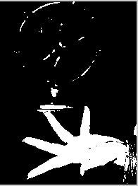


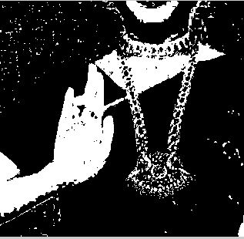

Image 96 Image 97 Image 98 Image 99
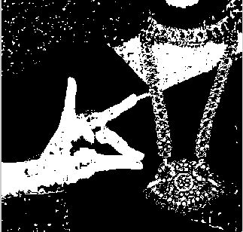
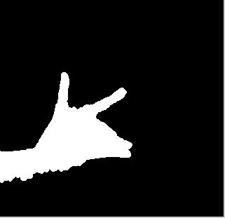
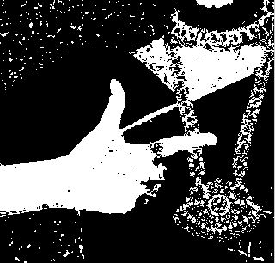


Image 100 Image 101 Image 102 Image 103

Observations:
- Eroding the image broke the small connectors, as the lining of the sari which was connecting the hand to the neck region
- The necklace touching the hand in image 102, has also been removed because of erosion
- Erosion did not cause distortion of the hand
- In image 96, the edge of the idol seems to be touching the hand, but because of erosion it has been removed
- Region were the ring was has been filled in image 103
- Similarly the gap between the fingers has been filled in image 101
- Conclusions:
- Erosion breaks small connectors
- Since only finger -tips and ends of fingers are important, region filling can be used to fill in the gaps between fingers
- Subprocess V & VI:
- Method:
      - Same as done for plain background
    - Results and Observations:

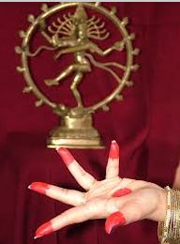
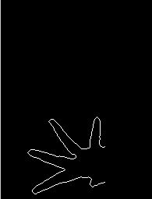
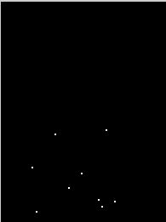

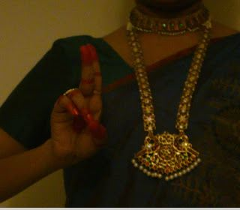
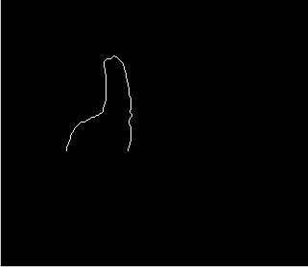
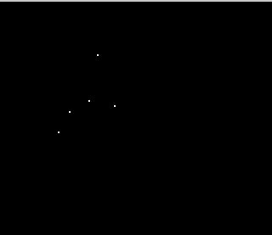

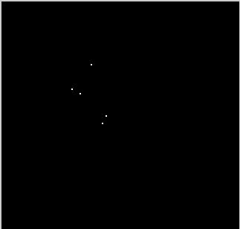
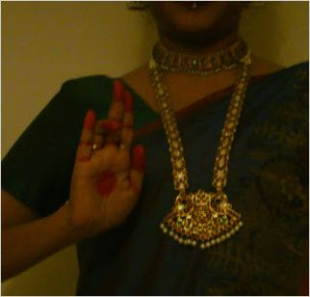


Observations and Conclusions:
      - Boundary extraction gave same results as for plain background because the hand was segmented out from background and then the processes were applied.
Overall Process:

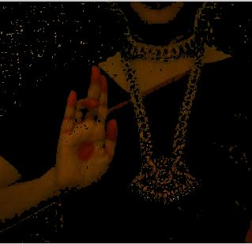

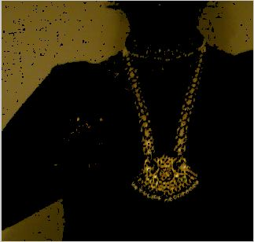
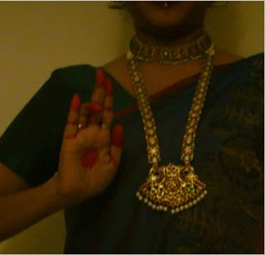
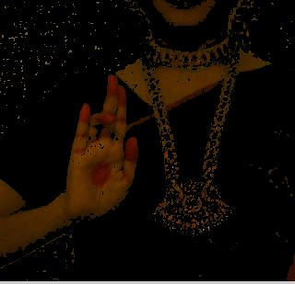
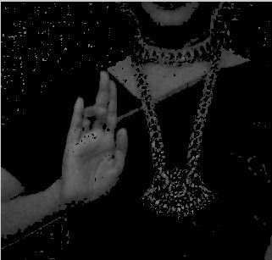

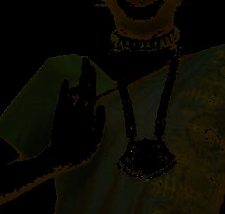
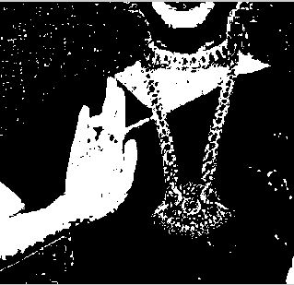

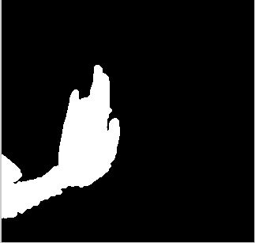

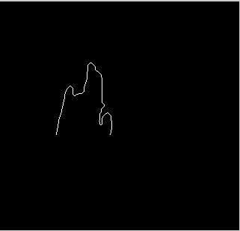
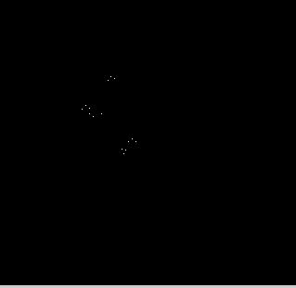
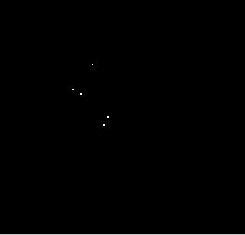

Extensions:
To make the code work for any of the cases in the three datasets, we have:
- Converted the image to HSV color space
- Identified the mode of each of the datasets in the H plane that distinguishes them.
- Applied the threshold according to the mode, and run the codes for each of the datasets according to the specifications
Observations: This was based on the observation that the first dataset had a blue background, so mode will be closer to 1, while the double hand mudras and single hand mudras in complex background usually had the colors of green and yellow, which will be near 0. And the plain background single hand mudras with accessories had a black background, so mode will be 0. Using this observation, we made the above process.
The pattern recognition part of the project can be done by applying a classifier to the fingers detected. But we have not concentrated on that part of the project as it is irrelevant to the course.

Successes and Failures:
Success: Single hand mudras have been properly segmented with and without accessories in plain and complex backgrounds
Failure: Double hand mudras were a bit of a challenge, because we were not able to distinguish between the hands, which caused a problem in feature extraction, because the boundaries were not properly extracted.

Conclusions and Knowledge Gain:
- Segmentation can be done using many methods based on type of dataset
- Segmentation is not a fixed process, but changes from dataset to dataset depending on what is wanted
- Analysis in the RGB plane does not give best results but it can be used as well.
- HSV plane is the best plane for analysis because of separation of color, saturation and intensity values.
- Morphological operations are useful in breaking small bonds, and filling in regions to get proper results.
- Neighborhood processing is very important for image processing. Most operations implemented require neighborhood processing.
- Feature extraction is a tricky matter, because there can be clashes between features.

- References:
- Rumyantsev, Oleg. "Recognition through Palm Gestures and Movements." Thesis. Stanford, 2012. Web. <http://www.stanford.edu/class/ee368/Project_12/Reports/Merati_Rumyantsev_Rachamandan_Hand_Sign_Recognition_Based_on_Palm_Gesture_and_Movement.pdf>.
- Singh, Devendra. "Human Face Detection by Using Skin Color Segmentation, Face Features and Regions Properties." Http://research.ijcaonline.org/volume38/number9/pxc3876881.pdf. N.p., n.d. Web.
- Gupta, Ankit. "Finger Tips Detection and Gesture Recognition." N.p., n.d. Web. <http://home.iitk.ac.in/~ashis/CS676Report.pdf>.
- Website
- "Asamyukta - Single Hand Gestures- Dances of India-Angika Abhinaya." Asamyukta - Single Hand Gestures- Dances of India-Angika Abhinaya. N.p., n.d. Web. 31 Oct. 2012. <http://www.webindia123.com/dances/abhinaya/angika_bhinaya/asamyukta.htm>

